


Youth employment
Provider reported services & outcomes
January to December 2025

Report produced August 2026
Market Strategy Branch

ndis.gov.au

Jack’s story

When Jack left school, he wasn’t sure what the future would hold.
The 22-year-old from Alkimos, a coastal suburb north of Perth, had spent time volunteering at a local Op shop, looking to build his confidence and social skills, all while gaining valuable experience. But despite his determination, finding paid work was difficult.
Today, Jack works across Optus Stadium and R A C Arena. He’s an event-day hospitality staff member, serving customers at major sporting events, concerts and functions.
He credits his chosen National Disability Insurance Scheme (NDIS) employment provider, Workpower and his individually matched employment mentor, John, for helping him develop the confidence, skills and experience needed to find and maintain work.
Jack, who has cerebral palsy and other disabilities, is funded through his NDIS plan for a range of supports, including physio and occupational therapies, assistive technology, social and community participation, transport and finding and keeping a job.
Dad, Andrew, said those supports helped Jack build important life skills and confidence.
‘Jack’s supports have been fantastic,’ Andrew said. ‘We’ve watched him grow into a lovely young man who enjoys what he does for work and he’s really good at it.’
As Jack was approaching the end of Year 12, his focus turned to employment.
Through his NDIS-funded employment supports, he worked closely with John, who helped him identify his strengths, build confidence and prepare him to join the workforce.
‘We started by looking at Jack’s resume, cover letters and job applications,’ John said.
‘We explored different workplaces, organised informational interviews and I helped Jack to learn more about the types of jobs he might enjoy.’
Together they visited businesses and explored potential career paths. John even arranged opportunities for Jack to observe different workplaces and they talked with each employer.
The process helped Jack discover what suited him and, just as importantly, what didn’t.
‘It was good to try different things,’ Jack said.
John also helped Jack complete his Responsible Service of Alcohol (RSA) certificate and supported him to build practical employment skills, including introducing himself to employers, handing out his resume and confidently discussing his abilities.

Transport training formed another important part of Jack’s employment journey.
Although he had done some travel training through school, John worked alongside him to practise travelling independently to and from work just to help ease any potential anxiety.
‘It really helped settle Jack in,’ Andrew said.

The breakthrough came when Jack was connected with Hospitality Disability Network Western Australia (HDNWA) and an employment opportunity with Optus Stadium.
Recognising Jack’s natural ability to connect with people, John felt the role would be a “perfect fit”.
‘Jack loves people,’ John said.
‘He’s charismatic and enjoys meeting new people and making their day a little brighter.’
After supporting Jack through the recruitment process, induction and initial shifts, John helped him gain confidence in the busy stadium environment.
‘When I first started, John shadowed me,’ Jack said. ‘But once I confidently learned the role, I was fine to work on my own.’
More than 3 years later, Jack continues to thrive.
He now works across Optus Stadium and R A C Arena, mainly in customer service and bar roles.
‘Right now, I do a lot of bartending,’ he said. ‘I crack cans, pour craft beers and do the tills.’
The job has also brought some unexpected highlights with Jack able to see some of his favourite artists live.
‘My favourites have been Coldplay, P!nk and Metallica,’ Jack said. ‘But Coldplay would have to be my favourite.’
Andrew said meaningful employment has had a significant impact on Jack’s confidence and independence.
‘Without all of this support, I don’t know where he would be,’ he said.
‘To have had to organise and provide all of this support on our own would have been near impossible. Now Jack’s got a job he enjoys, a routine and great experiences.’
John has also noticed the change.
‘Jack seems much more confident in himself,’ he said.
‘Meaningful work gives anyone the opportunity to use their strengths, meet new people and contribute. That’s exactly what it’s done!’
For Jack, having a job is about much more than earning money.
‘All this support has been great,’ he said. ‘It’s really improved my life.’
Now with the confidence, skills and experience Jack has built through his NDIS funding, particularly his employment supports, he knows there are still more opportunities ahead.

Contents
Youth employment 1
Contents 4
1. Executive summary 8
1.1 Introduction 8
1.2 NDIS Employment provider reporting 8
1.3 Report enhancements 8
1.4 Sharing outcomes 9
1.5 Key findings 10
2. Provider and participant count 13
2.1 Provider count 13
2.2 Participant count 14
3. Participant demographics 14
3.1 Employment assistance recipients 14
3.2 Location 15
3.3 Primary disability 16
3.4 Age 16
3.5 Gender 17
3.6 Aboriginal and Torres Strait Islanders status 17
3.7 Culturally and Linguistically Diverse status 18
4. Supports & milestones 19
4.1 Support type hours 19
4.2 Support delivery method 20
4.3 Progress towards milestones – snapshot at each reporting period 20
4.4 Progress towards milestones – cumulative for the year 22
5. Final outcomes 24
6. Final employment outcomes 27
6.1 Employment type 27
6.2 Hours worked 28
6.3 Industry of employment 29
6.4 NDIS supports in employment 30
6.5 Supported wages 30
7. Intermediate employment outcomes 31
7.1 Employment outcomes (January to December 2025) 31
7.2 Employment type 31
7.3 Hours worked 32
7.4 Industry of employment 33
7.5 NDIS supports in employment 34
7.6 Supported wages 34
8. Model summary 35
8.1 Modelling approach 35
8.2 Factors most associated with finding paid employment 36
8.3 Comparisons in modelled predictors between reporting period ending June 2025 versus the period ending December 2025 37
9. Appendix 38
9.1 Appendix 1 – Methodology for the section titled “Progress towards milestones – cumulative for the year” 38
9.2 Appendix 2 – Model accuracy 40

Executive summary

Introduction

The Agency is committed to ensuring participants have the same opportunities to work as other Australians and the confidence, support, and skills to achieve their work goals.

The NDIS can make a significant difference for young participants by supporting them early to aspire to work, develop skills and connect to the right job role and employer.
Employment assistance is individualised support intended to build a participant’s skills, confidence, and capacity for work.

This ninth edition of the Provider Quarterly Report analyses the early intervention employment assistance provided to participants still at school and those of school leaving age, their progress and the outcomes they’ve achieved, allowing us to share insights on best practice and the factors that lead to successful employment outcomes.

Since the first report was published in September 2022, the number of participants reported by providers has more than doubled, increasing from 4,530 to 9,215.

In the final quarter covered by each report, the number of providers reporting increased from 154 in September 2022 to 411 in the current report.

NDIS Employment provider reporting

NDIS Employment providers submit data to the NDIA on the employment assistance delivered to participants through the provider reporting tool (the tool) each quarter. The data submitted includes participants’ demographic details, activities, progress towards milestones, the method of delivery, outcomes achieved, and employment details. The provider confirms the details they are including, particularly the outcomes achieved, with the participant prior to submitting the report to the NDIA.

This report provides insights on the data submitted through the tool, aggregated across all providers’ that contributed from January to December 2025.

Report enhancements

To gain a greater understanding of early preparation for employment, from 1 July 2025 provider reporting requirements expanded to include participants who are still at school receiving support to gain additional work experience or their first part time job.
This is in addition to the school leaving cohort. As the number of school aged participants reported through the provider reporting tool builds we will progressively be able to share more detailed insights.

In line with expanded reporting requirements and new providers reporting, additional participants were reported in Q3 2025 and Q4 2025. Where a participant's service start date precedes the quarter in which they were first included in the reporting, they are included in the count for previous quarters. This has resulted in Q1 and Q2 2025 numbers being different to the same periods published in the previous report.

From 1 January 2026 reporting requirements will expand further to include:
- Participants aged 20+ with little or no work experience
- Participants working in open employment who need support to change jobs
- Participants finishing tertiary study who need help finding work that matches their qualifications.

Sharing outcomes
This report and the associated Outcomes by Provider list are a source of information participants can use when selecting a provider. We encourage participants to discuss with providers the services they deliver and the outcomes they achieve. Additional questions that participants can ask NDIS employment providers about their service are available here.

The report will feature a participant story, like Jack’s, in each release to showcase a positive employment outcome. Participants, or providers with the consent of the participant, are invited to forward stories to participant.employment@ndis.gov.au.

If you have general feedback or questions about this report, please email participant.employment@ndis.gov.au.

Key findings

The information contained in this report represents data submitted to the Agency by providers delivering employment assistance to young people still at school and school leavers delivered from January to December 2025.

For the 12 months ending December 2025, 9,601 young participants aged 15 to 24 had claimed payments for support items “school leaver employment supports” or “employment assistance”. This report includes only participants whose providers submitted data to the Agency. From this point, the term “employment assistance” is used to include both “employment assistance” and “school leaver employment supports”.

In the previous report covering the 12 months ending June 2025, the figure reported was 9,117 participants.

For the period January to December 2025, providers reported:

Demographics
- 9,215 participants received employment assistance to help them gain additional work experience or a part time job while still at school, or transition from school to work. 3,450 of whom commenced during the year.
- Commencement varies across quarters with the highest number starting in the January to March quarter after leaving school. 1,207 participants commenced receiving employment assistance in January to March 2025, 799 commenced in April to June 2025, 796 commenced in July to September 2025, and 648 commenced in October to December 2025.
- Young participants receiving employment assistance in the October to December 2025 quarter predominantly have autism (63%) or intellectual disability (27%), with 67% being male.
- The majority of employment assistance recipients are in N S W (33%), followed by V I C (23%), and Q L D (18%).
- 7% of employment assistance recipients identified as Aboriginal or Torres Strait Islander. This is slightly lower than the 9% of all NDIS participants aged 15-24 who identify as Aboriginal or Torres Strait Islander, and this gap has been consistent for the last few iterations of the report.
- 7% of employment assistance recipients identified as being from a Culturally and Linguistically Diverse community. This is slightly higher than the 6% of all NDIS participants aged 15 to 24 who identified as being from these communities. This gap has also been consistent for the last few iterations of the report.
Time spent in training
- 48% of the training time was spent building participant’s social, presentation, communication and work skills.
- Participants receive employment assistance via one to one support (51% of support time), group-based activities (48% of support time) and via distance or online methods (1%) in the latest quarter.

Exits from employment
- 2,763 participants were reported as exiting employment assistance during the four quarters.
- Of the 2,763 participants who exited:
  - 68% (1,868 out of 2,763) exited without an employment outcome compared to 64% (1,691 out of 2,633) in the previous report (1 year to 30 June 2025). *
  - 11% (307 out of 2,763) went on to further study or volunteer work compared to 12% (328 out of 2,633) in the previous report (1 year to 30 June 2025).
  - 18% (488 out of 2,763) achieved open employment outcomes compared to 20% (521 out of 2,633) in the previous report (1 year to 30 June 2025).
  - 4% (100 out of 2,763) achieved supported employment outcomes a job in supported employment services, previously Australian Disability Enterprises ADEs), and this proportion is equal to the 4% (93 out of 2,633) figure from the report of June 2025.
  - Less than 1% (8 out of 2,763) did not have an outcome reported.
- The number of open employment outcomes decreased from 521 to 488, while total exits increased from 2,633 to 2,763, resulting in a reduction in the open employment outcome proportion from 20% to 18%.
- *There were 2 key contributing factors leading to a reduction in open employment outcomes in this period:
1. One large provider ceased delivering services, with 268 affected participants subsequently referred to other providers. For reporting purposes, participants recorded as ‘referred to another provider’ are classified as non-employment outcomes, temporarily increasing the proportion of non-employment outcomes.
2. There was a 31% decrease in the open employment outcomes achieved with the assistance of DES / IEA compared to the previous report to June 2025. The introduction of the new specialist disability employment program Inclusive Employment Australia (IEA) in November 2025 may have contributed to this decrease. A shift in the provider landscape saw new IEA providers enter the market, some former Disability Employment Services (DES) providers exit the market, and changes in location of operation for some IEA providers. It is anticipated that this decrease will be temporary as NDIS employment providers establish connections with new IEA providers. Open employment outcomes achieved without the assistance of DES / IEA continue to rise. Please see the section 5 for the full breakdown of final outcomes, including those with the assistance of DES/ IEA.
- Of the participants who finished employment assistance with open and supported employment outcomes over the four quarters, 44% were employed on a part time basis while 39% were employed casually, 9% were employed full time.
- Of participants who finished employment support with paid employment:
  - 75% worked up to 21 hours per week.
  - 69% worked in retail, hospitality, tourism, trades, manufacturing or operations.
  - 27% said they will be using NDIS supports in employment to maintain their employment. Of participants who finished employment assistance with paid employment, 20% receive a wage determined under the Supported Wage System (S W S).

Interventions compared to outcomes
- Increased time receiving skill specific training was associated with a higher chance of making significant progress towards or fully gaining specific skills.
- Participants who made significant progress or fully achieved the following milestones were more likely to gain paid employment:
  - Employer engagement and job customisation
  - Work skills
  - Work experience.
Note: Figures in this report have been rounded to the nearest whole percentage.

Provider and participant count

Provider count

Figure 1. Providers claiming and reporting – October to December 2025
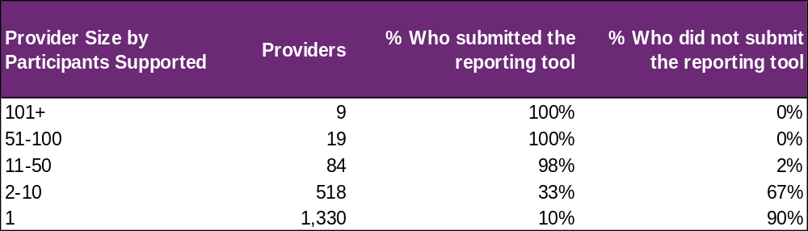

From October to December 2025 (Figure 1), NDIA recorded 1,960 providers claiming for employment assistance delivered to school aged participants and school leavers across the country, with 28 providers delivering to 51 or more participants. 84 providers delivered employment assistance to 11 to 50 participants and 1,848 providers delivered to 10 or fewer participants. The largest 28 providers delivered employment assistance to 33% of participants and reported on them all during the year. Across all of these providers, data was submitted for 69% of participants through the provider tool.

In the current reporting period, (Figure 2), providers who have 10 or fewer participants have lower submission rates. The proportion of providers submitting data over the 4 quarters has been fairly stable. The Agency is conducting further analysis of this cohort of providers and working to ensure compliance with mandatory reporting requirements.

Figure 2. Percentage of providers who submitted the reporting tool – January to December 2025

Participant count

Figure 3. Participants represented in reporting – January to December 2025
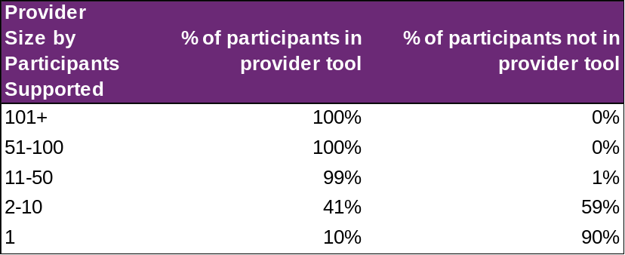

Overall, 31% of school-aged and school-leaving participants who received employment assistance in the last quarter were not represented in reporting submitted by providers. This increased from 27% in the previous report to 30 June 2025 which only included school leaving participants. Whilst providers servicing 11 or more participants has remained stable there has been an increase in the number of smaller providers claiming for services. Smaller providers tend to have a lower submission rate historically.

Participant demographics

Employment assistance recipients

The Provider Reporting Tool data provides information on participants receiving employment assistance during the year. Participants that started employment support during a previous period and continue to be recipients in the current period are included in the ‘Existing’ numbers, and those that started receiving employment during the current period are included in the ‘New’ numbers. While participants that exited employment assistance during the current period are included in the ‘Exited’ numbers.

Note, if the participant exits employment assistance in a quarter, they will be counted in the "Exit" numbers for that quarter. If that same participant re-enters employment assistance a few quarters later, they will be counted in the "New" numbers again.

Figure 4. Number of participants
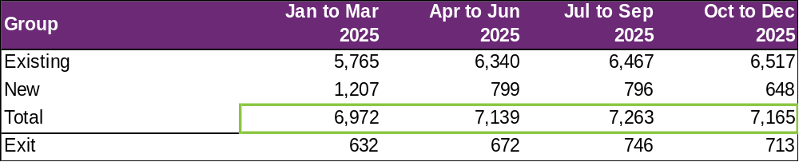

The number of participants receiving employment assistance reported in the Provider Reporting Tool (the Tool) has steadily increased over the first 3 quarters, with a slight decrease in the fourth quarter.

Many young people transition out of school between October to December (after Year 12), which creates a surge in commencements (1,207 in the Jan to Mar 2025 quarter) as they look for assistance to pursue their work goals.

Conversely, the end of the year often aligns with support completion (typically after 2 years for school leavers). However, exits have grown over the first 3 quarters, with a slight dip in the fourth quarter. This is roughly in-line with the growing number of participants receiving employment assistance during the calendar year.

Please note that the numbers of participants reported in this report for the January to March 2025 quarter and the April to June 2025 quarter differ from the numbers for those same periods in the previous edition report. This may be due to a combination of late reporting or expanded reporting where a new cohort of participants were included in the last two quarters (July to December 2025). That is, the participants had not been reported when the previous edition report was compiled but have since been reported and are included in the current report.

Location

Figure 5. State or Territory of residence – number of participants
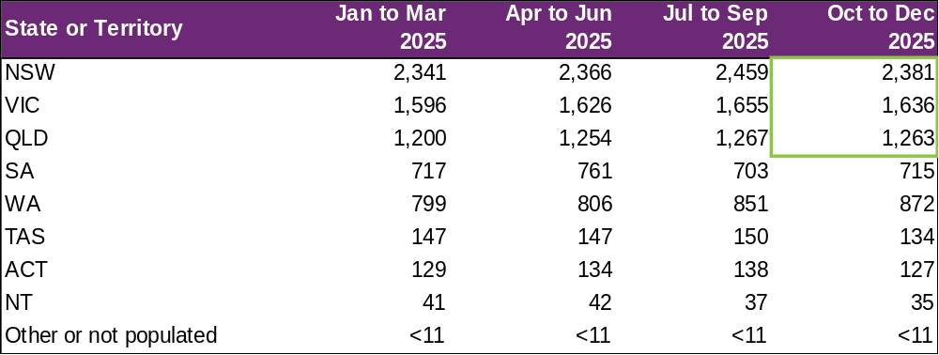

The majority of employment assistance recipients were in NSW (33%), followed by VIC (23%), and QLD (18%). For comparison, the top 3 states for all NDIS participants aged 15-24 are NSW (29%), VIC (27%) and QLD (21%). The over-representation in NSW is partly due to the earlier roll out to full scheme in that state and the influence of the legacy NSW Transition to Work program and the role of NSW Education transition teachers helping students to consider post school options and connecting many with employment providers.

Primary disability

Figure 6. Primary disability – number of participants
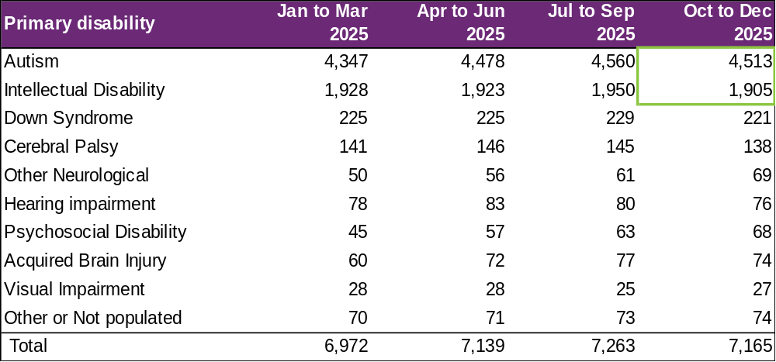
The most common primary disabilities experienced by participants utilising employment assistance in the latest quarter were autism (63%), followed by intellectual disability (27%). For comparison, 68% and 17% of all NDIS participants aged 15-24 report having autism and intellectual disability, respectively.

Age

Figure 7. Age – percentage of participants
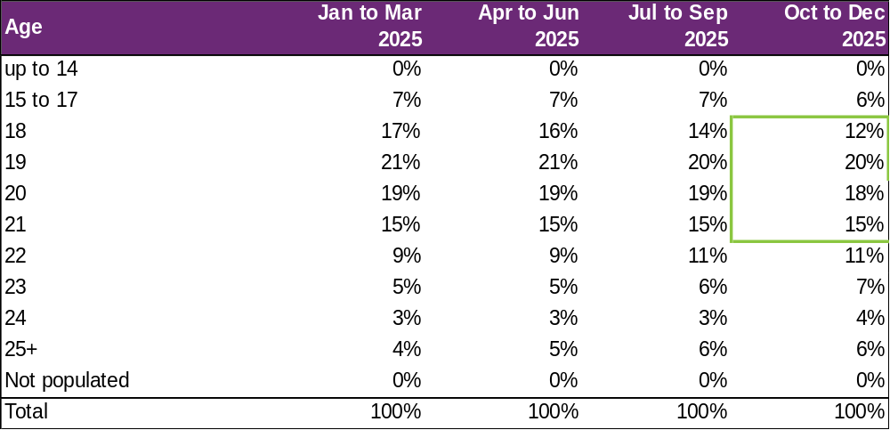

Participants aged 18 to 21 accounted for 65% of employment assistance recipients. Recipients aged 22 and over has steadily grown in proportion over the 4 quarters, while the proportion of recipients aged 15 to 20 has reduced. This is likely a mix of natural ageing of the cohort, participants connecting with providers after leaving school, and providers continuing to report on the participants they are supporting.

From 1 July 2025, both the claiming and provider reporting cohorts were expanded to include participants under the age of 18 who claimed Employment Assistance. While this expansion increased the number of participants captured in the claiming data, it would not necessarily be expected to result in an increase in the proportion of participants aged 15 to 17 from July to September 2025. Participants newly captured through the reporting expansion may have commenced employment support in an earlier quarter and are therefore retrospectively added to the figures for that earlier quarter. The slight decrease in the proportion of participants aged 15 to 17 is due to a combination of exits and participants ageing out of the age group, with age measured at the end of each quarter.

Gender

Figure 8. Gender – percentage of participants
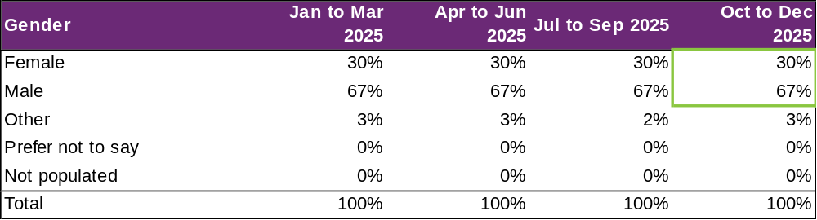

In the most recent quarter, employment assistance recipients were 30% female and 67% male. In comparison to all NDIS participants aged 15 to 24, 36% were female and 62% were male. This is in line with the high proportion of employment assistance recipients reporting autism as the primary disability, as the majority of participants who report autism are males.

Aboriginal and Torres Strait Islanders status

Figure 9. Aboriginal and Torres Strait Islanders – percentage of participants
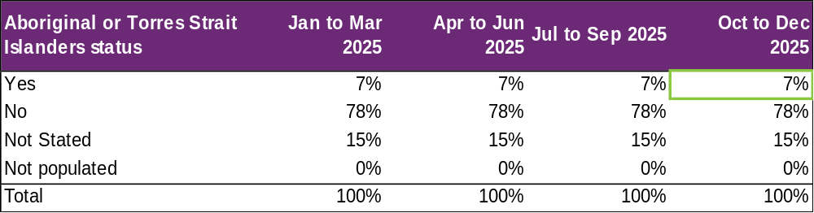

In the most recent period, 7% of employment assistance recipients identified as Aboriginal and / or Torres Strait Islander. This is slightly lower than the 9% of all NDIS participants aged 15-24 who identified as Aboriginal and / or Torres Strait Islander. This gap has been consistent for the last few iterations of the report.

Culturally and Linguistically Diverse status

Figure 10. Culturally and linguistically diverse – percentage of participants
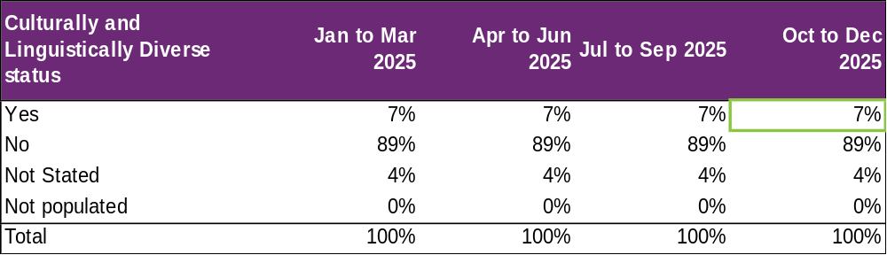

In the most recent period, around 7% of employment assistance recipients identified as being from a Culturally and Linguistically Diverse community. This is slightly higher than the 6% of all NDIS participants aged 15 to 24 who identified as being from a Culturally and Linguistically Diverse community. This gap has been consistent for the last few iterations of the report.

Supports & milestones

Support type hours

Figure 11. Support type provided – percentage of average hours per participant
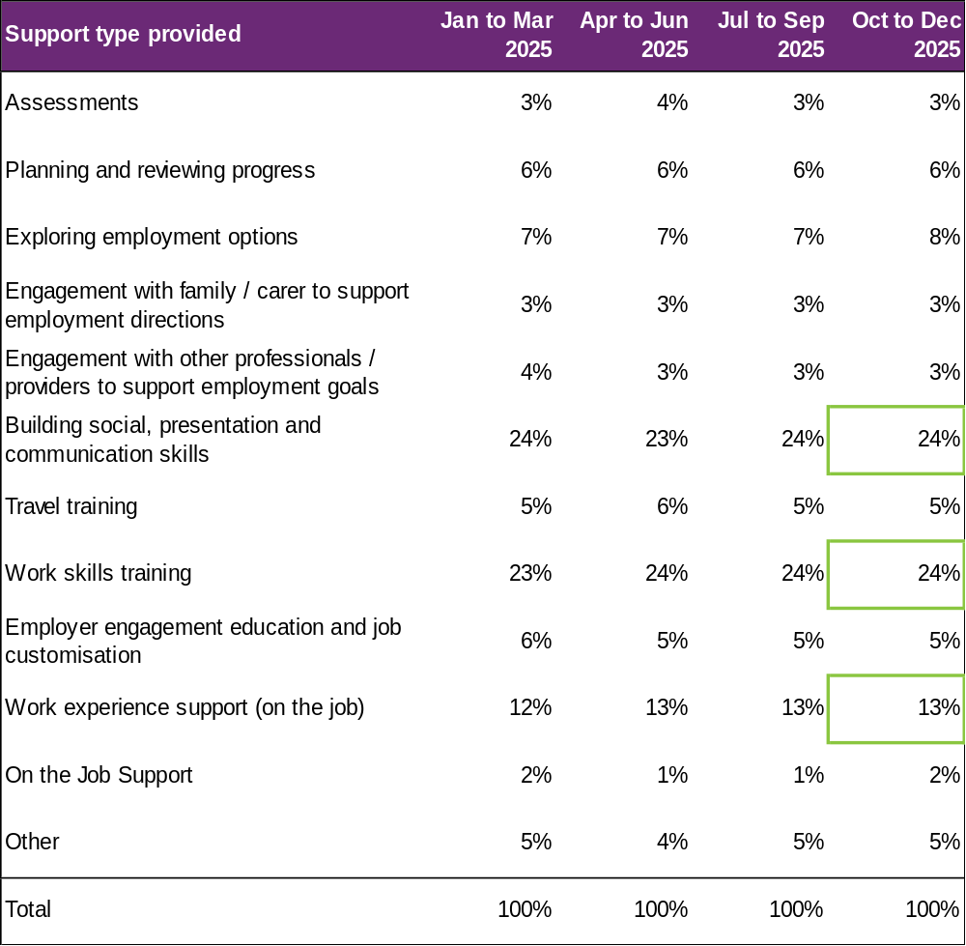

Almost half (48%) of the training time was spent building participants’ social, presentation, communication, and work skills. The amount of time dedicated to work experience support (on the job) has accounted for 13% of the total training time. Percentages across the board have remained steady over the four quarters.

Support delivery method

Figure 12. Delivery method – percentage of hours
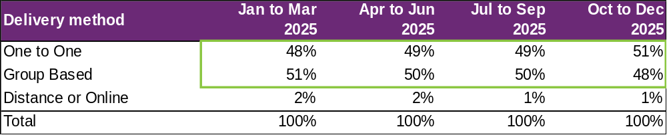
The percentage of one-to-one support has grown over the 4 quarters, compared to group based and distance or online delivery methods which have decreased.

Note: Participants have been excluded from this section where the sum of One to One, Group based, Distance or Online percentages did not equal 100%.

Progress towards milestones – snapshot at each reporting period
This section looks at the distribution of progress for participants who worked on a particular milestone (where there are training hours reported for that specific skill), for each reporting period in isolation (non-cumulative).

Social, presentation and communication skill

Figure 13. Social, presentation and communication skill milestone – percentage of participant progress
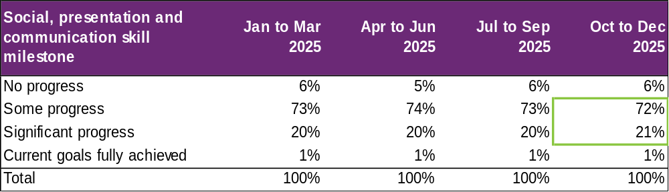

For participants who worked on this specific milestone, 72% reported some progress and 21% reported significant progress in the latest reporting period. Percentages have remained relatively consistent over the 4 quarters.

Travel skill

Figure 14. Travel skill milestone – percentage of participant progress
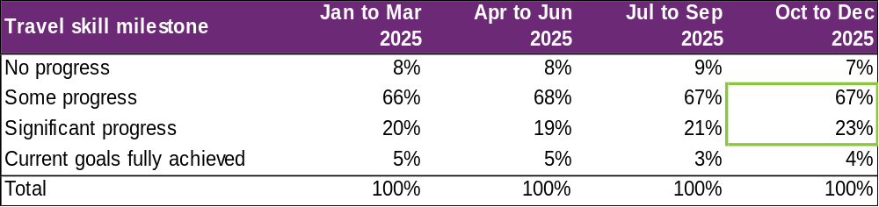

For participants who worked on this specific milestone, 67% reported some progress and 23% reported significant progress in the last quarter. The percentage reporting significant progress has increased by 3% over the four quarters.

Work skill

Figure 15. Work skill milestone – percentage of participant progress
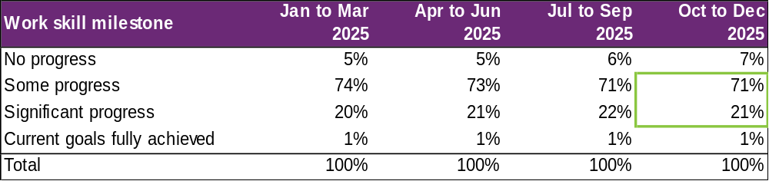

For participants who worked on this specific milestone, 71% reported some progress and 21% reported significant progress. The percentage of participants reporting some progress has decreased over the four quarters, while those reporting no progress has increased.

Employer engagement, education, and job customization

Figure 16. Employer engagement, education, and job customisation milestone – percentage of participant progress
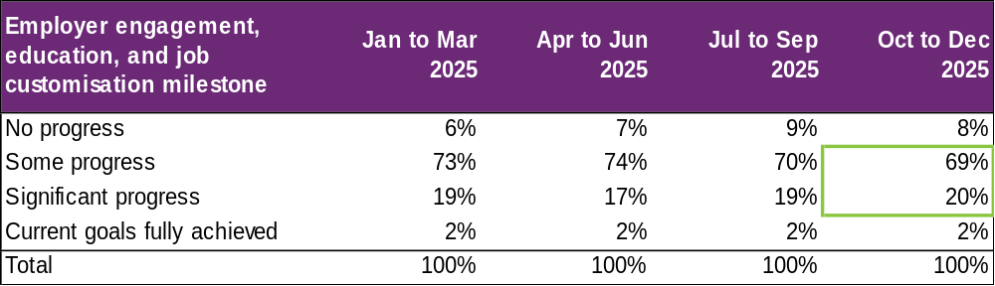

Providers who reported activities as “engaging with employers, educating and customising jobs” for participants reported that 69% made some progress and 20% made significant progress. There was a slight increase in those making significant progress in the last quarter and a decrease in those making some progress.

Work experience

Figure 17. Work experience milestone – percentage of participant progress
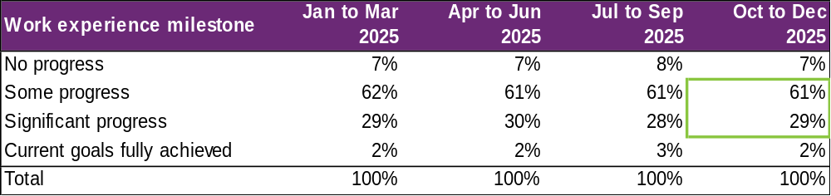

For participants undertaking work experience, 61% were reported to be making some progress and 29% making significant progress in the most recent quarter. Percentages have remained relatively consistent over the four quarters.

Progress towards milestones – cumulative for the year

The following sections show that more time receiving supports or training is associated with better progress towards mastering specific skills. For each participant, the best progress (across 4 quarters) towards mastering the specific skills is used for this analysis, and compared against the cumulative time receiving employment assistance, and training for the specific skills.

Appendix 1 includes more detail on the methodology used in this section.

Social, presentation and communication skill

Figure 18. Social, presentation and communication skill milestone – percentage of participant progress
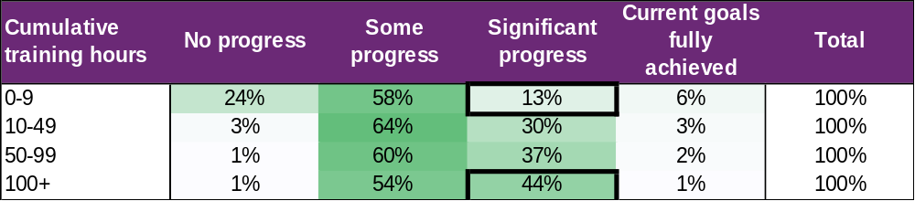

Of the participants who received up to 9 hours of training on social, presentation, and communication skills, around 13% were able to make significant progress towards mastering these skills. This proportion increased to 44% for those who received 100+ hours of the skill-specific training.

Travel skill

Figure 19. Travel skill milestone – percentage of participant progress
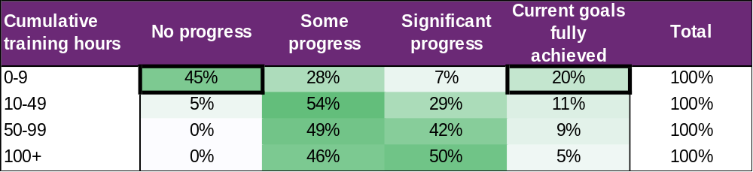

While 20% participants were able to fully achieve their goal within 0-9 hours of training, about half (45%) did not make any progress. This suggests that for some participants, travel skills may be a primary area of focus requiring only a few hours of personalised support to fully achieve their goals, while others need more than 10 hours of training to start making progress towards their goals.
Note that the unusually decreasing percentage of participants with current goals fully achieved as cumulative training hours increase is due to small counts (hence percentage volatility) in this category.

Work skill

Figure 20. Work skill milestone – percentage of participant progress
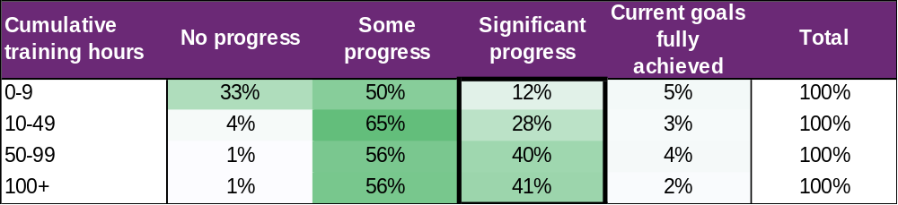

Attaining significant progress in work skills was achieved through more cumulative hours of training demonstrating the need for tailoring this support for the individual.

Employer engagement, education, and job customisation

Figure 21. Employer engagement, education, and job customisation milestone – percentage of participant progress
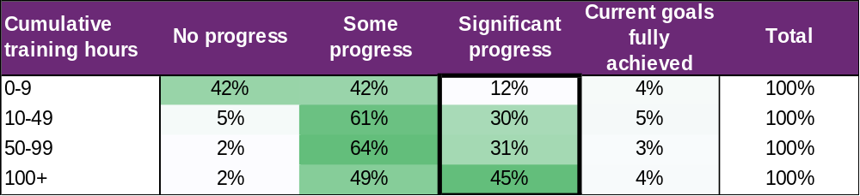

Making significant progress towards employer engagement, education, and job customisation milestones increased markedly with more hours spent on these activities.

Work experience

Figure 22. Work experience milestone – percentage of participant progress
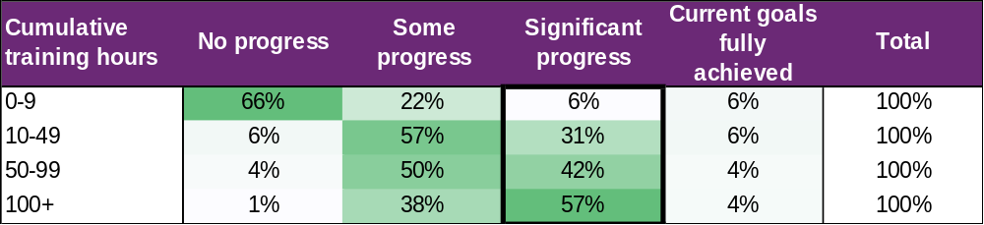

Similarly, making significant progress towards work experience milestones increased consistently with more hours of training.

Final outcomes

This section shows the distribution of outcomes upon exiting employment assistance (based on the employment support reported end/exit date).

Figure 23. Final outcomes (upon exiting employment assistance) – number of participants
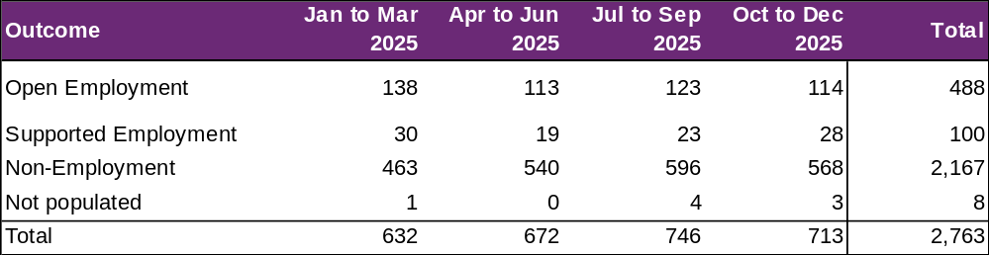

The number of participants finishing employment assistance with open or supported employment increased over the four quarters, with a slight decrease in the fourth quarter.

From January to December 2025, 588 participants finished employment support with open or supported employment.

Figure 24. Final outcomes (upon exiting employment support) – percentage of participants
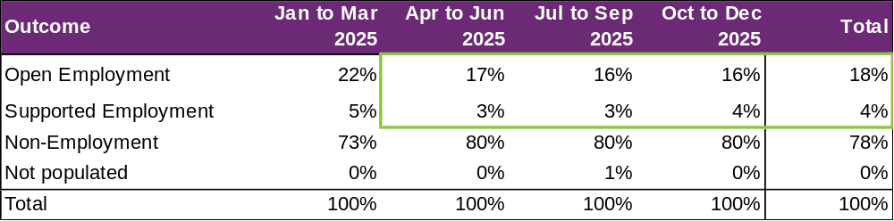

Non-employment outcomes rose in the April to June 2025 quarter, leading to the drop in the proportion of open employment outcomes. As outlined in the key findings section (section 1.4), the main reason for this is one large provider ceased delivering services in that quarter, with 268 affected participants subsequently referred to other providers. For reporting purposes, participants recorded as ‘referred to another provider’ are classified as non-employment outcomes, temporarily increasing the proportion of non-employment outcomes.

There was also a decrease in the number of open employment outcomes achieved with the assistance of Disability Employment Services (DES) / Inclusive Employment Australia (IEA). As outlined in the key findings section this coincides with the commencement of the new specialist disability employment program Inclusive Employment Australia (IEA) in November 2025. This impact is expected to be temporary as NDIS and new IEA providers establish connections.

The Agency is working in partnership with the Department of Social Services to strengthen connections between NDIS employment supports and supports provided through IEA. The Agency will make improvements to the provider reporting tool to better monitor collaboration between NDIS employment providers and IEA providers.

The following table provides a more granular breakdown of outcomes for participants who exited employment assistance from January to December 2025.

Figure 25. Final outcomes breakdown – percentage and total number of participants:
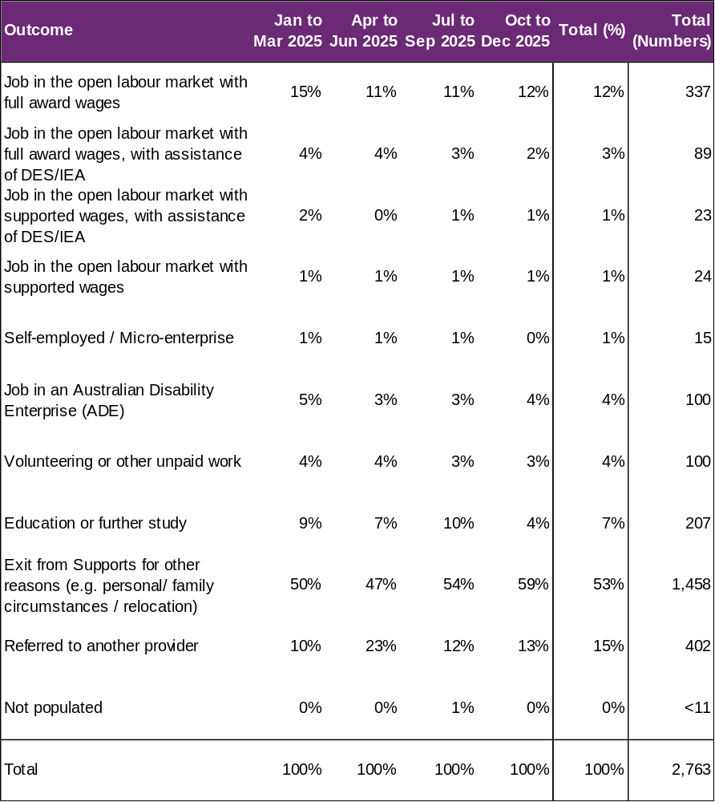

The absolute numbers (non-percentages) have been shown as a total only in the above table (not broken down into individual quarters) due to low volumes in the individual quarter. Individual quarter absolute numbers will be shown once there is sufficient volume.

There was a 31% decrease in the number of open employment outcomes achieved with the assistance of DES / IEA in this reporting period. With a total of 163 open employment outcomes achieved with the assistance of DES reported in the 12 months to June 2025 compared to 112 outcomes in the current report to December 2025. This coincides with the commencement of Inclusive Employment Australia.

There were modest increases in the open employment outcomes achieved without the assistance of DES / IEA.

Open employment outcomes comprise of:
- jobs in the open labour market, with full award or supported wages, with or without the assistance of Disability Employment Services (D E S)/ Inclusive Employment Australia (IEA)
- or Self-employment/Micro-enterprise.

A job in a supported employment service (previously known as Australian Disability Enterprise (A D E)) is classified as Supported Employment. The other categories in the chart above are classified as non-employment outcomes.

For participants whose final outcome is Exit from Supports for other reasons, the common reasons reported were:
- personal or family circumstances
- relocated
- not engaging or contactable
- NDIS employment funding ended
- transferred to D E S/IEA or another provider
- not a good fit or ready for employment preparation.

Figure 26. Final outcomes breakdown – participants in open and supported employment, by primary disability – percentage:
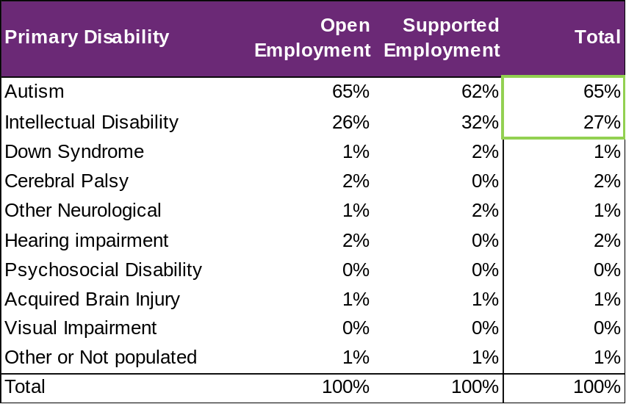

There is a slight over-representation of participants with a primary disability of autism who finished in employment - 65% finished in employment versus 63% who received support (from section 3.3).

On the other hand, primary disability of intellectual disability seems to be fairly represented - 27% finished in employment versus 27% who received support (from section 3.3).

Final employment outcomes

Employment type

Figure 27. Employment type – number of participants
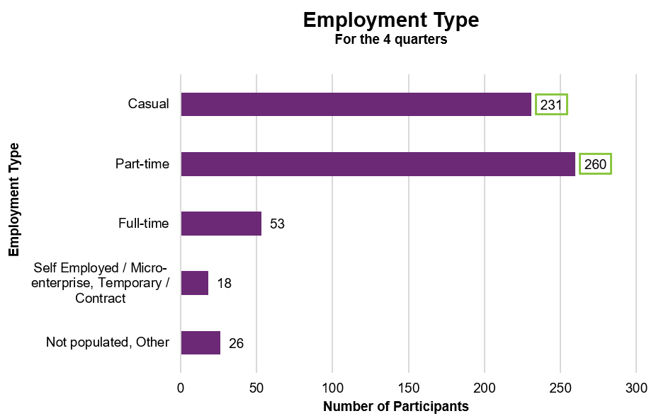

From January to December 2025, of participants who finished employment assistance with paid employment, 231 gained casual work while 260 gained part-time work.

Figure 28. Employment type – percentage of participants
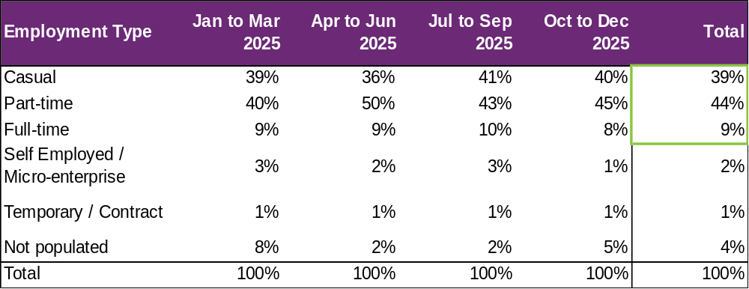

From January to December 2025, of participants who finished employment assistance with paid employment, 39% gained casual work while 44% gained part-time work and 9% gained full-time work.

These numbers tend to be somewhat volatile from quarter to quarter due to small counts.

Hours worked

Figure 29. Hours worked per week – percentage of participants
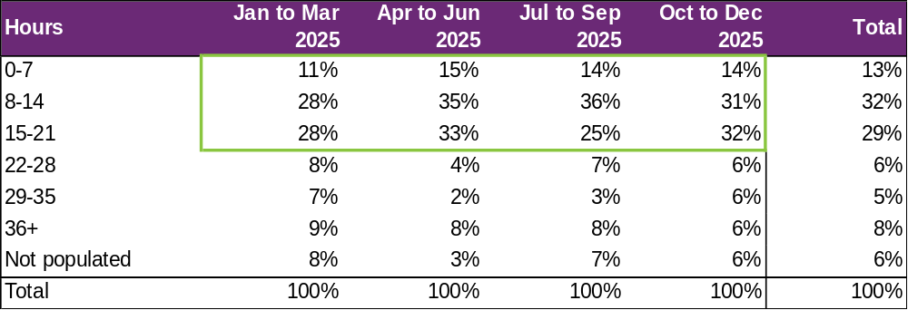

From January to December 2025, of participants who finished employment assistance with paid employment, there has been an increase in those who worked up to 21 hours per week over the four quarters. However, as mentioned previously, these numbers tend to be quite volatile between quarters due to small counts.

75% of participants who finished employment support with paid employment worked up to 21 hours per week.

Industry of employment

Figure 30. Industry of employment – percentage of participants
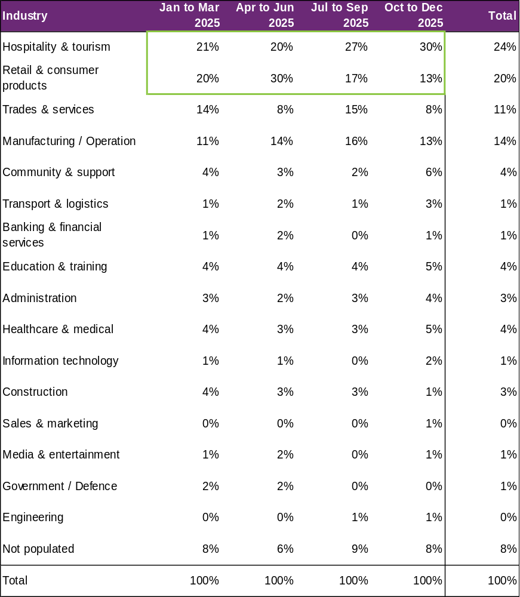

The percentage of participants who worked in hospitality and tourism as well as retail and consumer products fluctuated over the four quarters, with a large increase overall for the former and a large decrease for the latter. Both are still the top two industries for participants to be employed in over the last four quarters.

From January to December 2025, of participants who finished employment assistance with paid employment, 69% work in Hospitality, Tourism, Retail, Trades, Manufacturing, or Operation.

NDIS supports in employment

Figure 31. Will the participant be utilising NDIS supports in employment? – percentage of participants
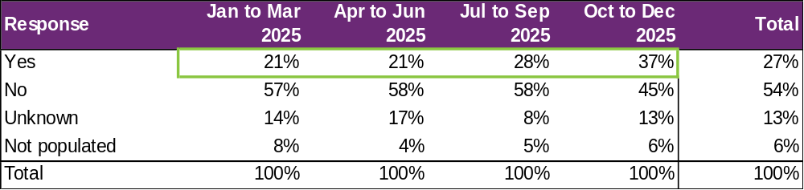

The percentage of participants that will be utilising NDIS supports in employment to maintain their employment has increased substantially over the four quarters.

For the 2025 calendar year, providers reported 27% of participants who finished employment assistance with paid employment will be using NDIS supports in employment to maintain their employment. This is an increase from the 21% figure in the eighth version of this report for financial year 2025.

Supported wages

Figure 32. Will the participant receive a wage determined under the supported wage system? - Percentage of participants
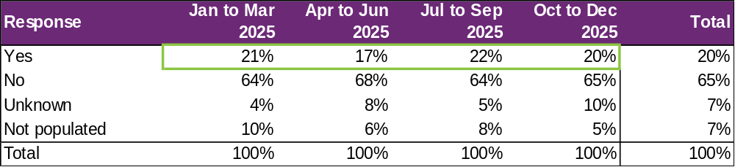

Of participants who finished employment assistance with paid employment, the percentage who were reported to receive a wage determined under the Supported Wage System (S W S) has fluctuated over the four quarters and seen a slight decrease overall. These numbers are in line with the changing mix of open employment vs supported employment outcomes reported in each quarter.
Over the 12 months, 20% of participants who commenced paid employment receive a wage determined under the S W S.

Intermediate employment outcomes

This section contains the employment features for all the participants who commenced employment from January to December 2025. The participants may or may not have exited employment assistance during this period. Participants with Employment Type "Work Experience" are excluded.

Employment outcomes (January to December 2025)
1,208 participants started in paid employment
37% of participants worked between 15 and 36 hours
Up from 1,059 in the June 2025 report

The top 4 industries in which participants started employment were Retail, Hospitality/Tourism, Trades/Services and Manufacturing/Operations.

Employment type

Figure 33. Employment type – number of participants
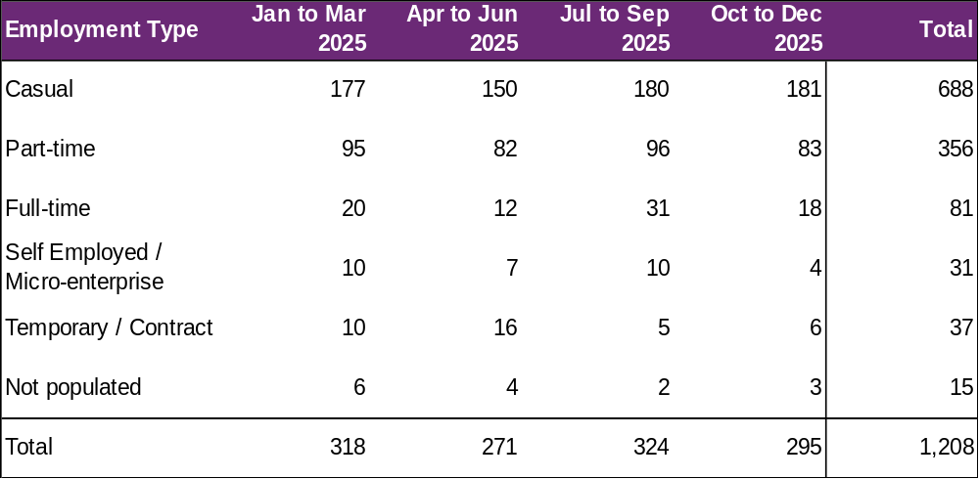

The number of participants commencing casual and part-time employment fluctuated across the four quarters, with a drop in the April to June 2025 quarter.

A total of 1,208 participants were reported to have commenced employment from January to December 2025. During this period, 688 started casual work while 356 started part-time work.

Figure 34. Employment type – percentage of participants
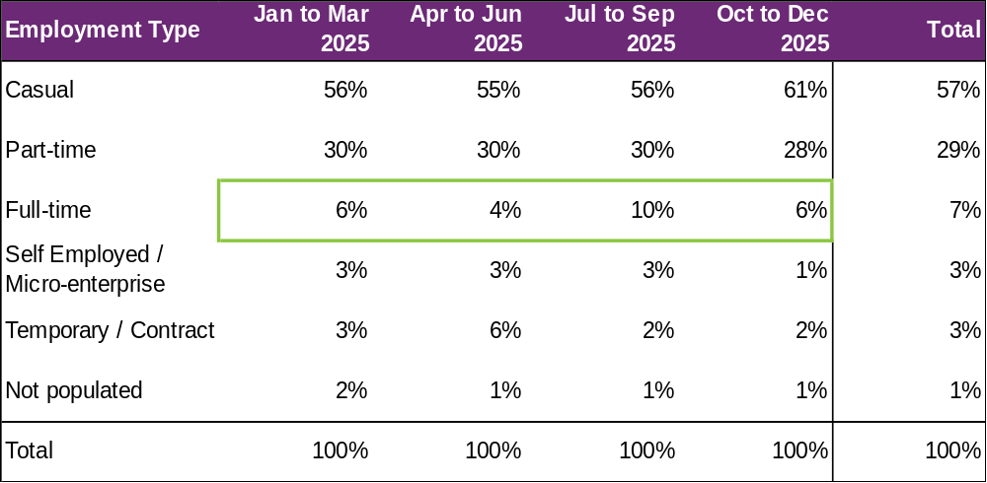

The percentage of participants who started full-time work fluctuated during the period, totalling 7% for the 4 quarters (in-line with the previous report to June 2025).

From January to December 2025, of participants who started employment, 57% started casual work, while 29% started part-time work.

Hours worked

Figure 35. Hours worked per week – percentage of participants
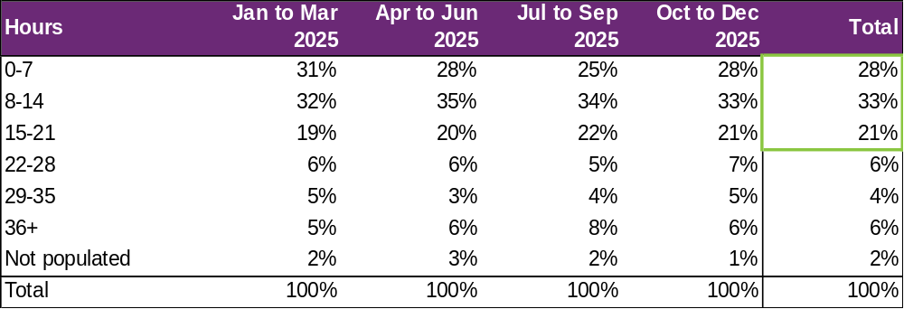

From January to December 2025, of participants who started employment, 82% worked up to 21 hours per week.

Percentages fluctuated between quarters, with all categories of employment hours having no consistent trend up or down.

Industry of employment

Figure 36. Industry of employment – percentage of participants
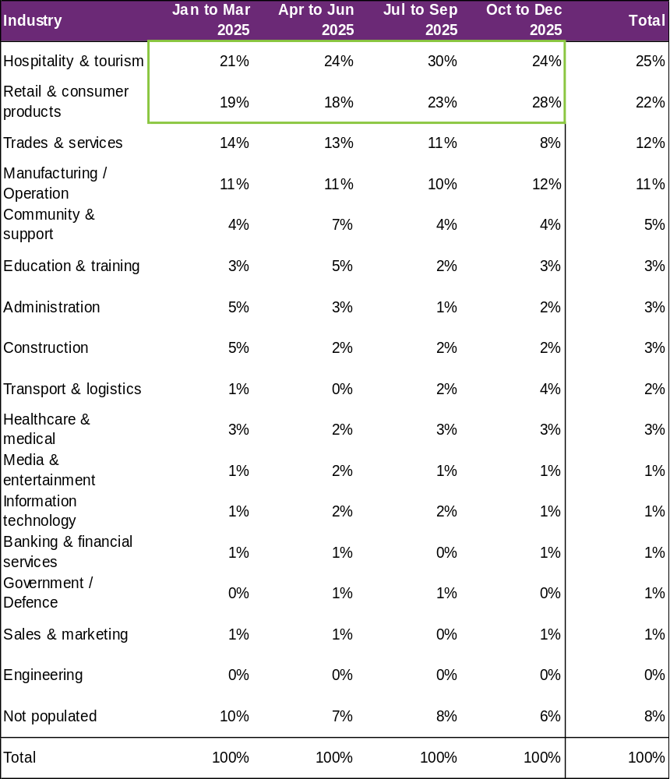

The percentage who worked in hospitality and tourism as well as retail and consumer products increased significantly over the 4 quarters, while the percentage who worked in trades and services declined substantially.
From January to December 2025, of participants who started employment, 70% worked in Hospitality and tourism, Retail and consumer products, Trades and services, Manufacturing or Operation.

NDIS supports in employment

Figure 37. Will the participant be utilising NDIS supports in employment? – percentage of participants
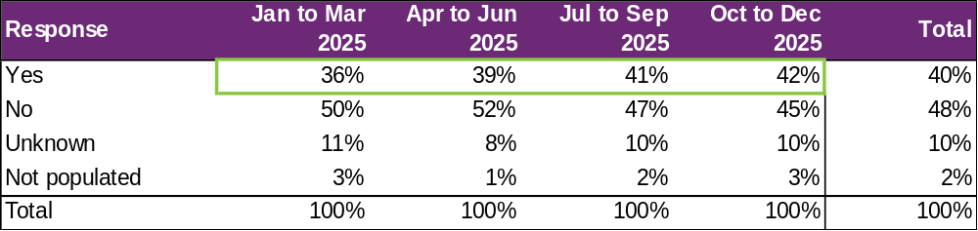

From January to December 2025, of participants who started employment, providers report 40% will be using NDIS supports in employment to maintain their employment.

This is an increase versus the 36% figure in the June 2025 report and is a trend that has continued from previous reports.

Supported wages

Figure 38. Will the participant receive a wage determined under the supported wage system? - Percentage of participants
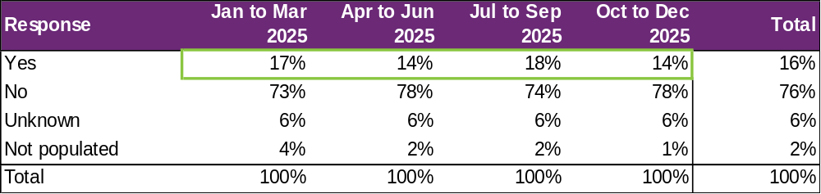

This percentage has fluctuated over the four quarters with no clear trend.

For the year, providers report 16% of the participants who started employment will receive a wage determined under the Supported Wage System (S W S).

Model summary

Modelling approach
A model was built to predict successful employment outcomes, defined as any of the following:
- Job in the open labour market, with full award or supported wages, with or without the assistance of Disability Employment Services (D E S)
- Self-employed / Micro-enterprise
- Supported employment.
The modelling dataset is sourced from the Provider Reporting Tool and NDIA’s own participant data, with the former containing outcomes and support hours and the latter containing characteristics such as Culturally and Linguistically Diverse Status and education activities.
In addition, Socio-Economic Indexes for Areas (S E I F A) data was attached to the modelling dataset, mapping to the 2021 LGA. Note that some LGA names in the Provider Tool were updated to the 2021 LGA due to changes in LGA boundaries between 2016-2021.
The analysis employed an XGBoost machine learning model, an advanced implementation of the Gradient Boosting Machine, to model the relationship between finding paid employment and its key drivers.
The top drivers of finding paid employment, that providers have most direct influence on (ranked in order from most to least important), are:
- Progress made towards achieving employer engagement and job customisation milestones.
- Progress made towards achieving work experience support milestones.
- Progress made towards achieving work skills milestones.
- Hours spent in work experience support.
- Hours spent in work skills development.
Appendix 2 has more details on the accuracy of the model.

Factors most associated with finding paid employment
Figure 39. Factors most associated with finding paid employment – for the model covering period ending in December 2025.
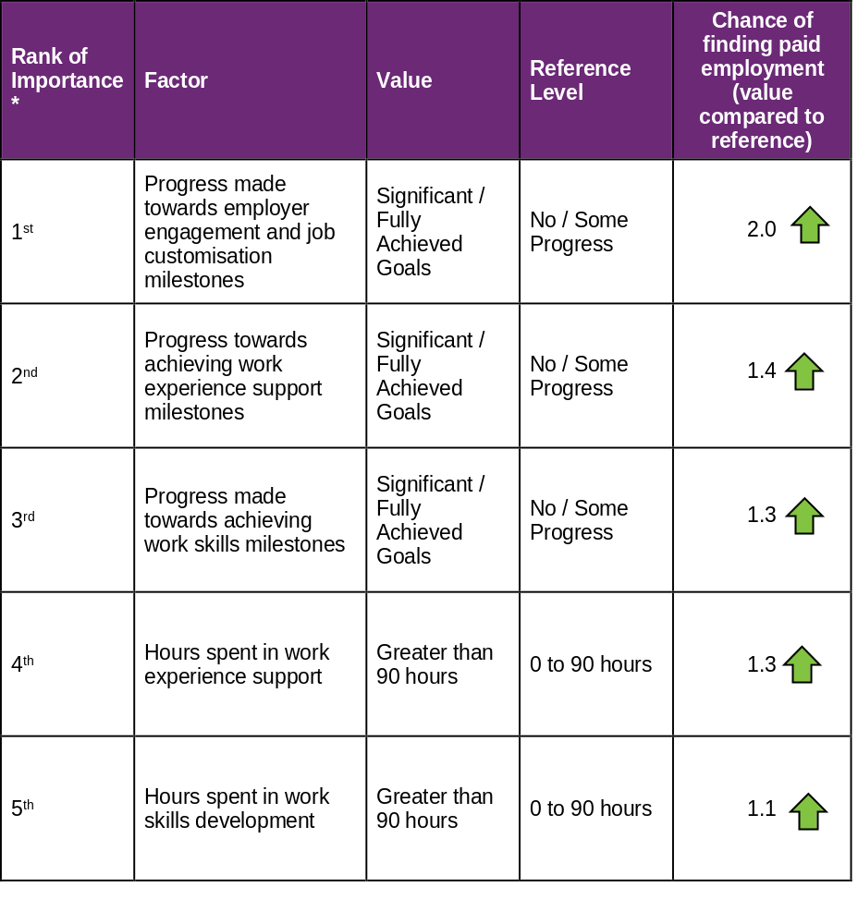
How to interpret the above table:
- Participants who made significant progress towards or fully achieved their employer engagement, education, and job customisation milestones were 2 times as likely to find employment compared to participants who made no or some progress towards similar milestones.
- Participants who were spent 90+ hours in work experience support are 1.3 times as likely to find employment compared to participants who spent up to 90 hours in work experience support.

Comparisons in modelled predictors between reporting period ending June 2025 versus the period ending December 2025
The following table provides a comparison of the top five most significant predictors in the model covering the period ending in June 2025, versus the model covering the period ending in December 2025.

Figure 41. Comparison of the top five most significant predictors
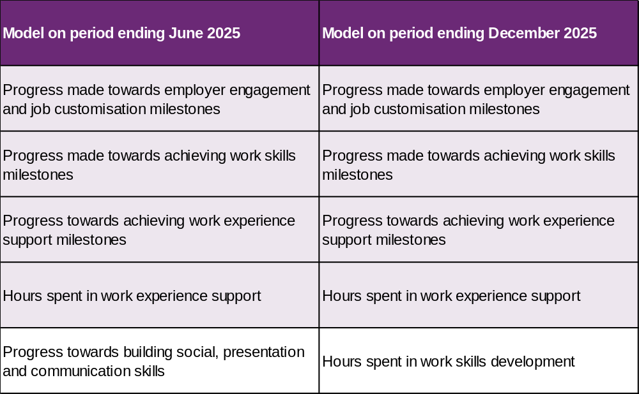

As shown above, the predictor “Progress towards building social, presentation and communication skills” was significant in the model covering the period ending June 2025 but no longer in the top 5 for the model covering the period ending December 2025. This predictor has been replaced by “Hours spent in work skills development in the top 5.

The modelling insights from the period ending December 2025 data are based on 4,361 observations, which is more than the 3,845 observations used to model the period ending June 2025. These additional observations have led to a slight change in significant predictors although most have stayed the same.

Appendix

Appendix 1 – Methodology for the section titled “Progress towards milestones – cumulative for the year”
This Appendix provides more details on how to interpret the section titled “Progress towards milestones – cumulative for the year,” and the methodology used.
How to interpret the table below

Work experience milestone – percentage of participant progress

Out of all participants who have received 100+ hours of on-the-job work experience support (cumulative for the year)
- 1% have "No progress" as the best result for the year.
- 38% have "Some progress" as the best result for the year.
- 57% have "Significant progress" as the best result for the year.
- 4% have "Current goals fully achieved" as the best result for the year.
The sum of each row in the above table equals 100%.

Methodology (for cumulative training hours)
The starting universe is all participants reported in the Provider Reporting Tool across the 4 quarters. For each participant, the "cumulative training hours" is then calculated as the total of the milestone-specific training hours reported in the Provider Tool for the 4 quarters. The best progress for the specific milestone is used (of all progress entries reported in the Provider Reporting Tool across the 4 quarters).
For example, if for participant John Smith, below are the progresses and hours reported across the 4 quarters.
Work experience support (on the job)
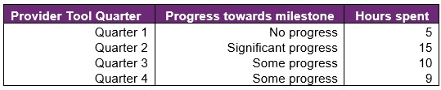
then "cumulative training hours" = 39 = 5 + 15 + 10 + 9 and the progress selected for John is "Significant progress" (the best progress of the 4 quarters). The "cumulative training hours" is then rounded down to the nearest whole number (e.g., 6.75 is rounded down to 6), and grouped into bands. Then for each cumulative training hours group (e.g., 0-9), the percentage of participants in each (best) progress category is calculated so that the sum of the row is 100%.

Appendix 2 – Model accuracy

The XGBoost model presented in Section 8 has the following accuracy:
Figure 42. Model accuracy – Gini and AUC
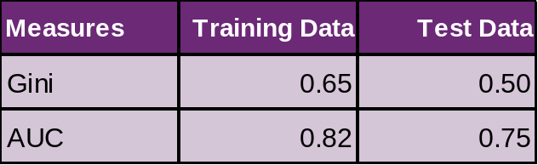
The closer the test set AUC and Gini is to 1, the better the model performance.
There is a moderate difference between training data Gini (0.65) and test data Gini (0.5), indicating some overfitting but an acceptable amount.
The Test Data AUC (and Gini) is typically lower than the Training Data AUC (and Gini). This is because the model was built on the Training Data, hence predicts more accurately on it. The Test Data Gini and AUC however, give an indication of the model prediction accuracy when the model predicts on unseen data (on which it was not built).
Figure 43. Model accuracy – receiver operating curve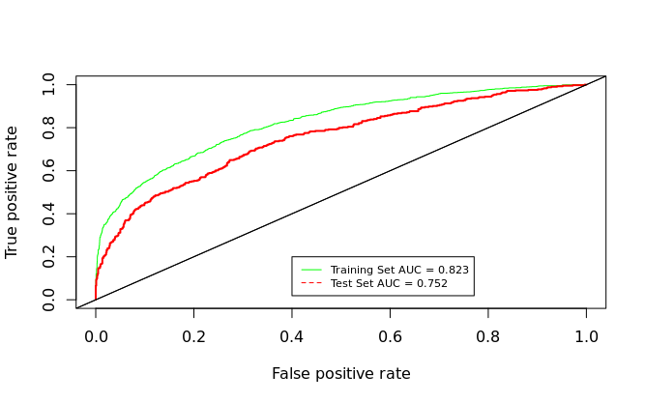

Figure 44. Model accuracy – actual versus predicted
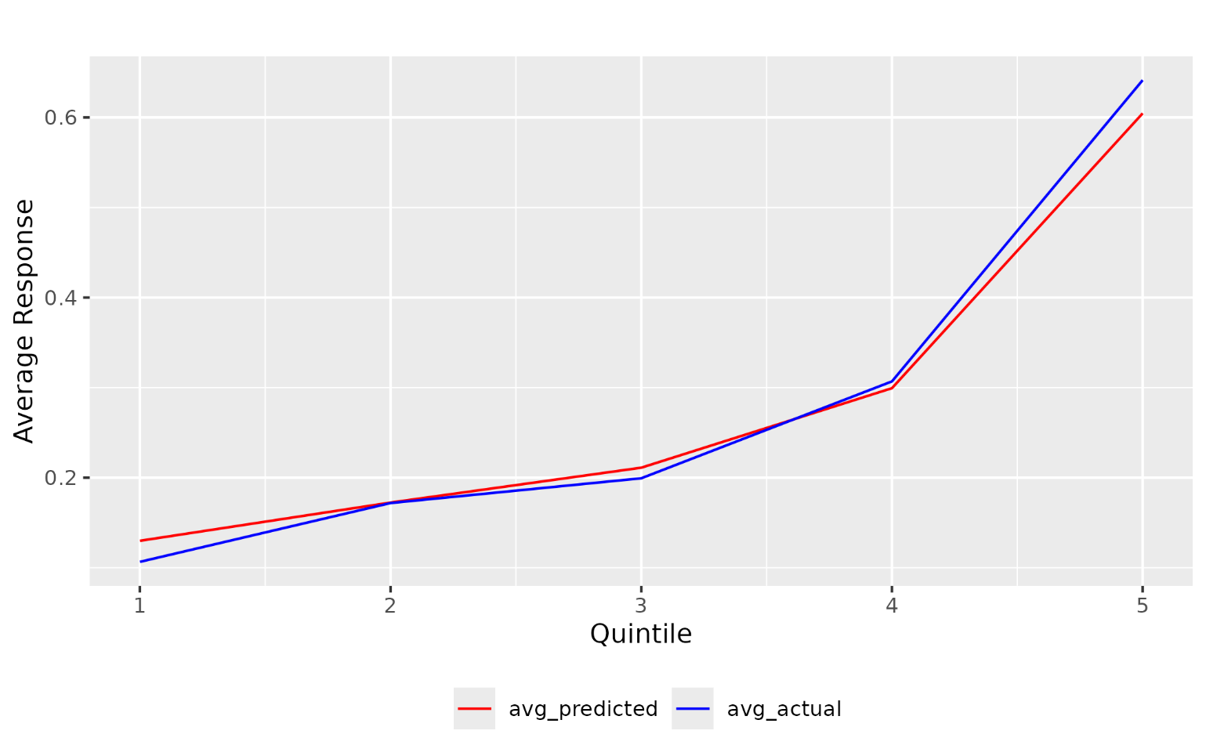

The model predicted probability (red) curve is close to the actual outcome (blue) curve, indicating that the model is able to accurately predict the probability of recipients finding paid employment.

Source: Australian Bureau of Statistics. For further information: Socio-Economic Indexes for Areas (SEIFA): Technical Paper, 2021 | Australian Bureau of Statistics (abs.gov.au) Link to the data: Socio-Economic Indexes for Areas (SEIFA), Australia, 2021 | Australian Bureau of Statistics (abs.gov.au) - Local Government Area, SA1 Distributions, SEIFA 2021.xlsx

